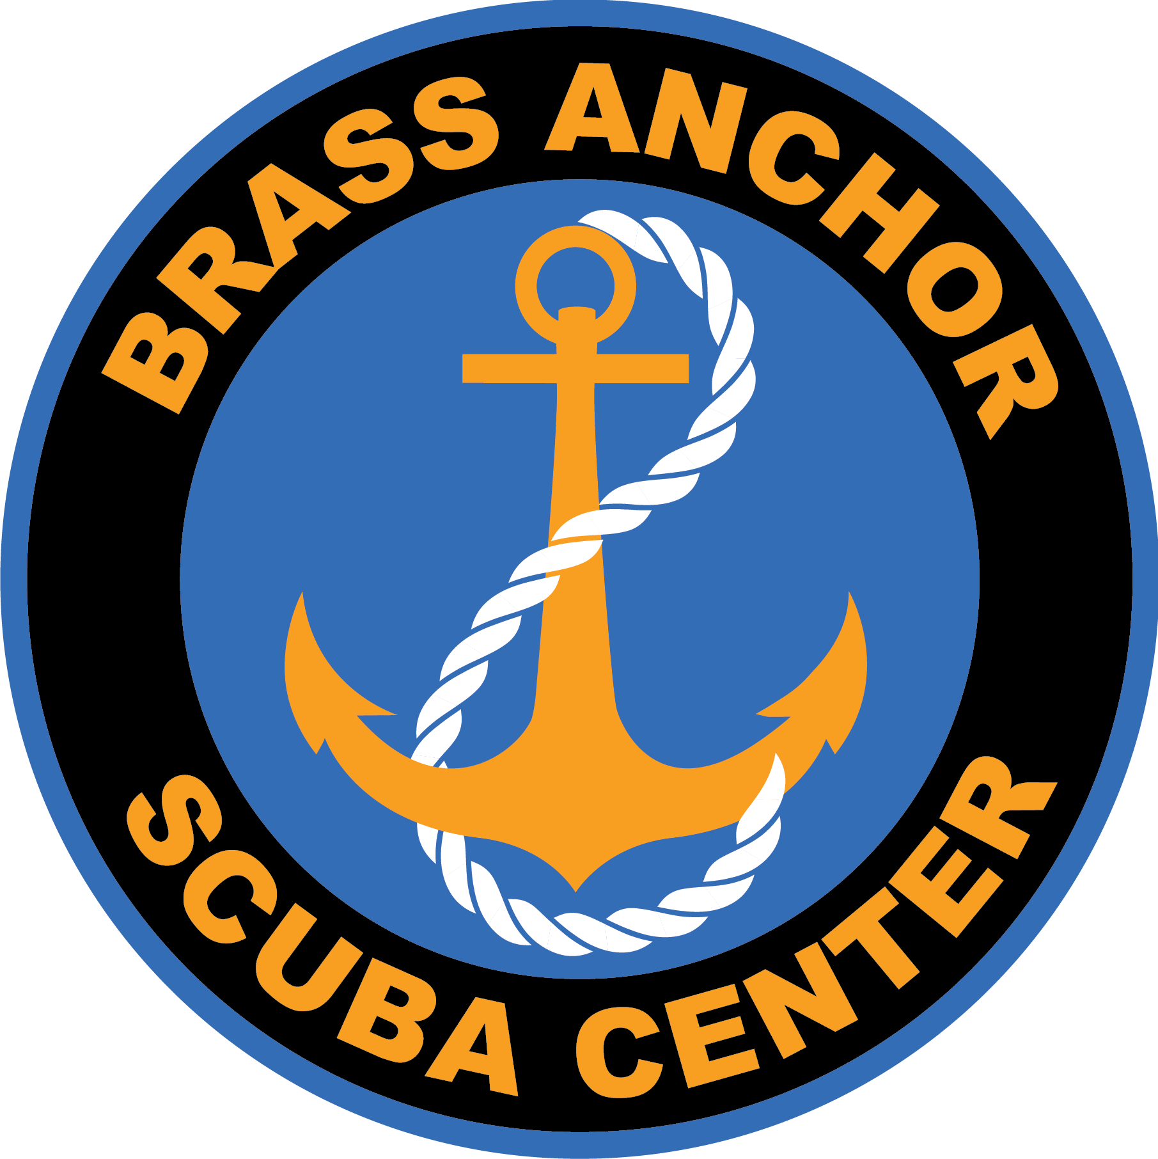
North Carolina Wreck Diving
June 2nd to June 4th,2023 JJJuneJune7thJuly12th, 2020 ,22020

The Atlantic Ocean off Morehead City offers some of the best warm water wreck diving in America. What makes this trip unique?
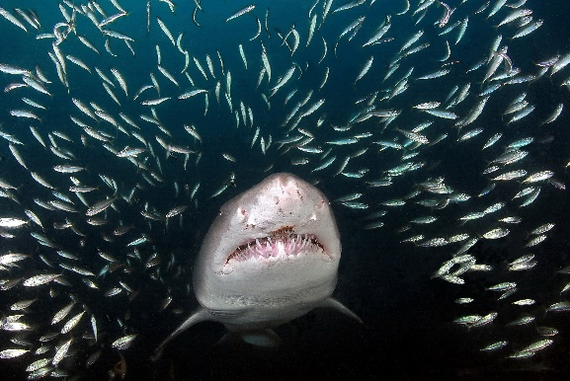
If conditions are good, witness history firsthand; dive a World War II German U-Boat that was sunk by a U.S. Coast Guard vessel during the 1940s.
We will be allowing some extended bottom times for rebreathers and decompression-trained divers. Please consult The Brass Anchor if this is the type of diving you plan on doing this trip.
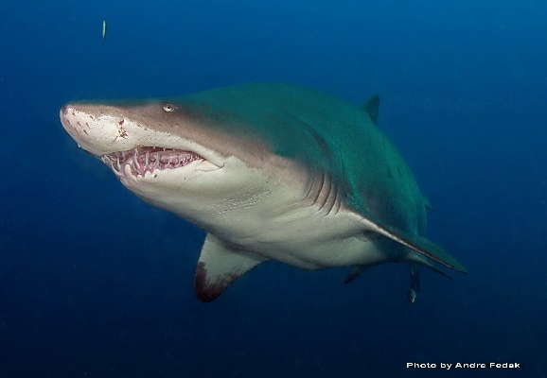
Sand tiger sharks are found on most wrecks in this area.
Loggerheads, spadefish, toadfish and barracuda have been seen frequently on dives.
Three days of diving; 2 offshore wreck dives per day.

We will be diving with Discovery Diving in Beaufort, NC, one of the longest running dive operations in the area. If the dive conditions are good, there are few places in the world as amazing as some of these wrecks. Join us for an unforgettable adventure. Sign up today to reserve your spot. Accommodations are not included in the price but will be available at a group price once the trip list is full. Or you can make your own arrangement for accommodations.

The Trip at a Glance
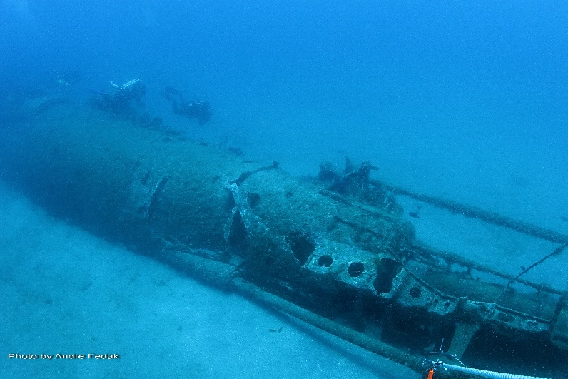
Dates: June 2nd,3rd and 4th
Aug . 10th,11th and 12th
Cost: $450 per diver
Deposit: $100 due on sign up..
before May 1, 2018

Included:
3 days, 2 offshore wreck dives per day
Boat : Outrageous 5

Not Included:
NITROX or NITROX cylinders Air/Nitrox fills in North Carolina Meals and beverages Accommodations in NC. Transportation to NC

Contact: Brass Anchor @ 301-663-9363, email: andre@brassanchor.com,
www.brassanchor.com

